AWS setup

1. Create one Bucket “Orchestrator” on S3

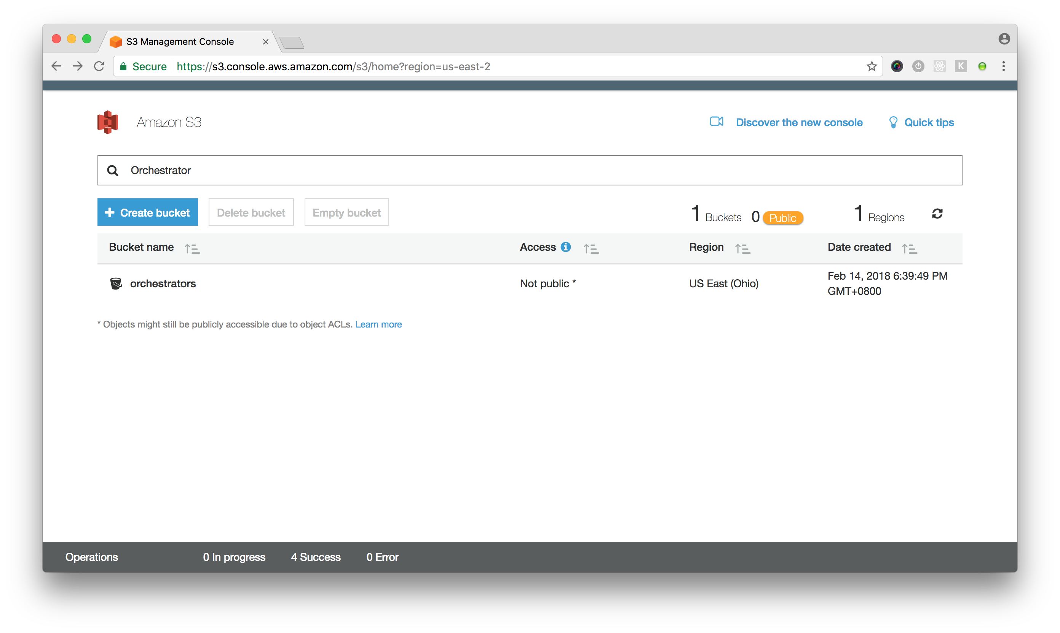

1. Create one Lambda function “S3_Unzip”

You can check the entry file “index.js” and it’s comments

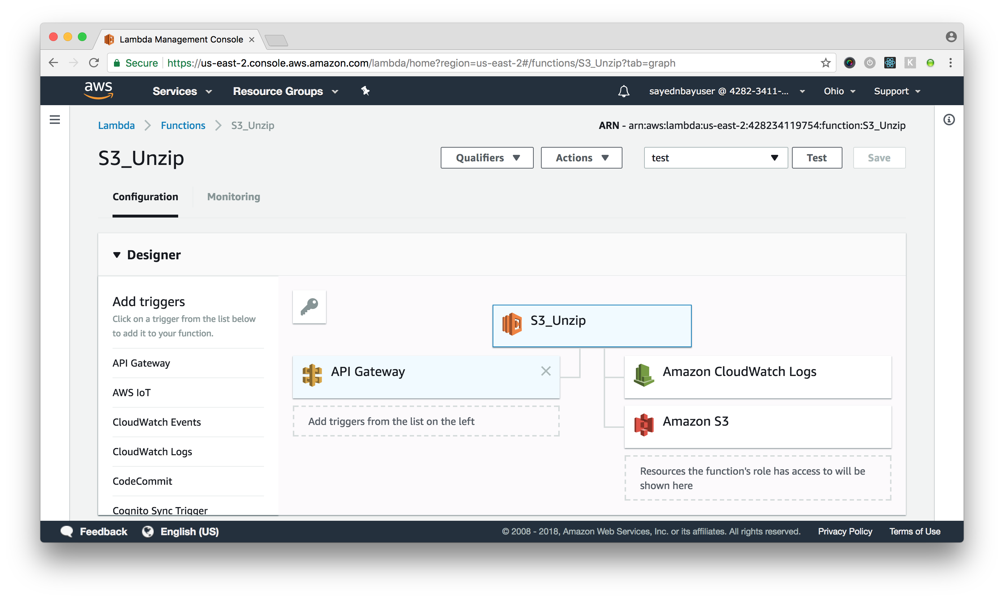

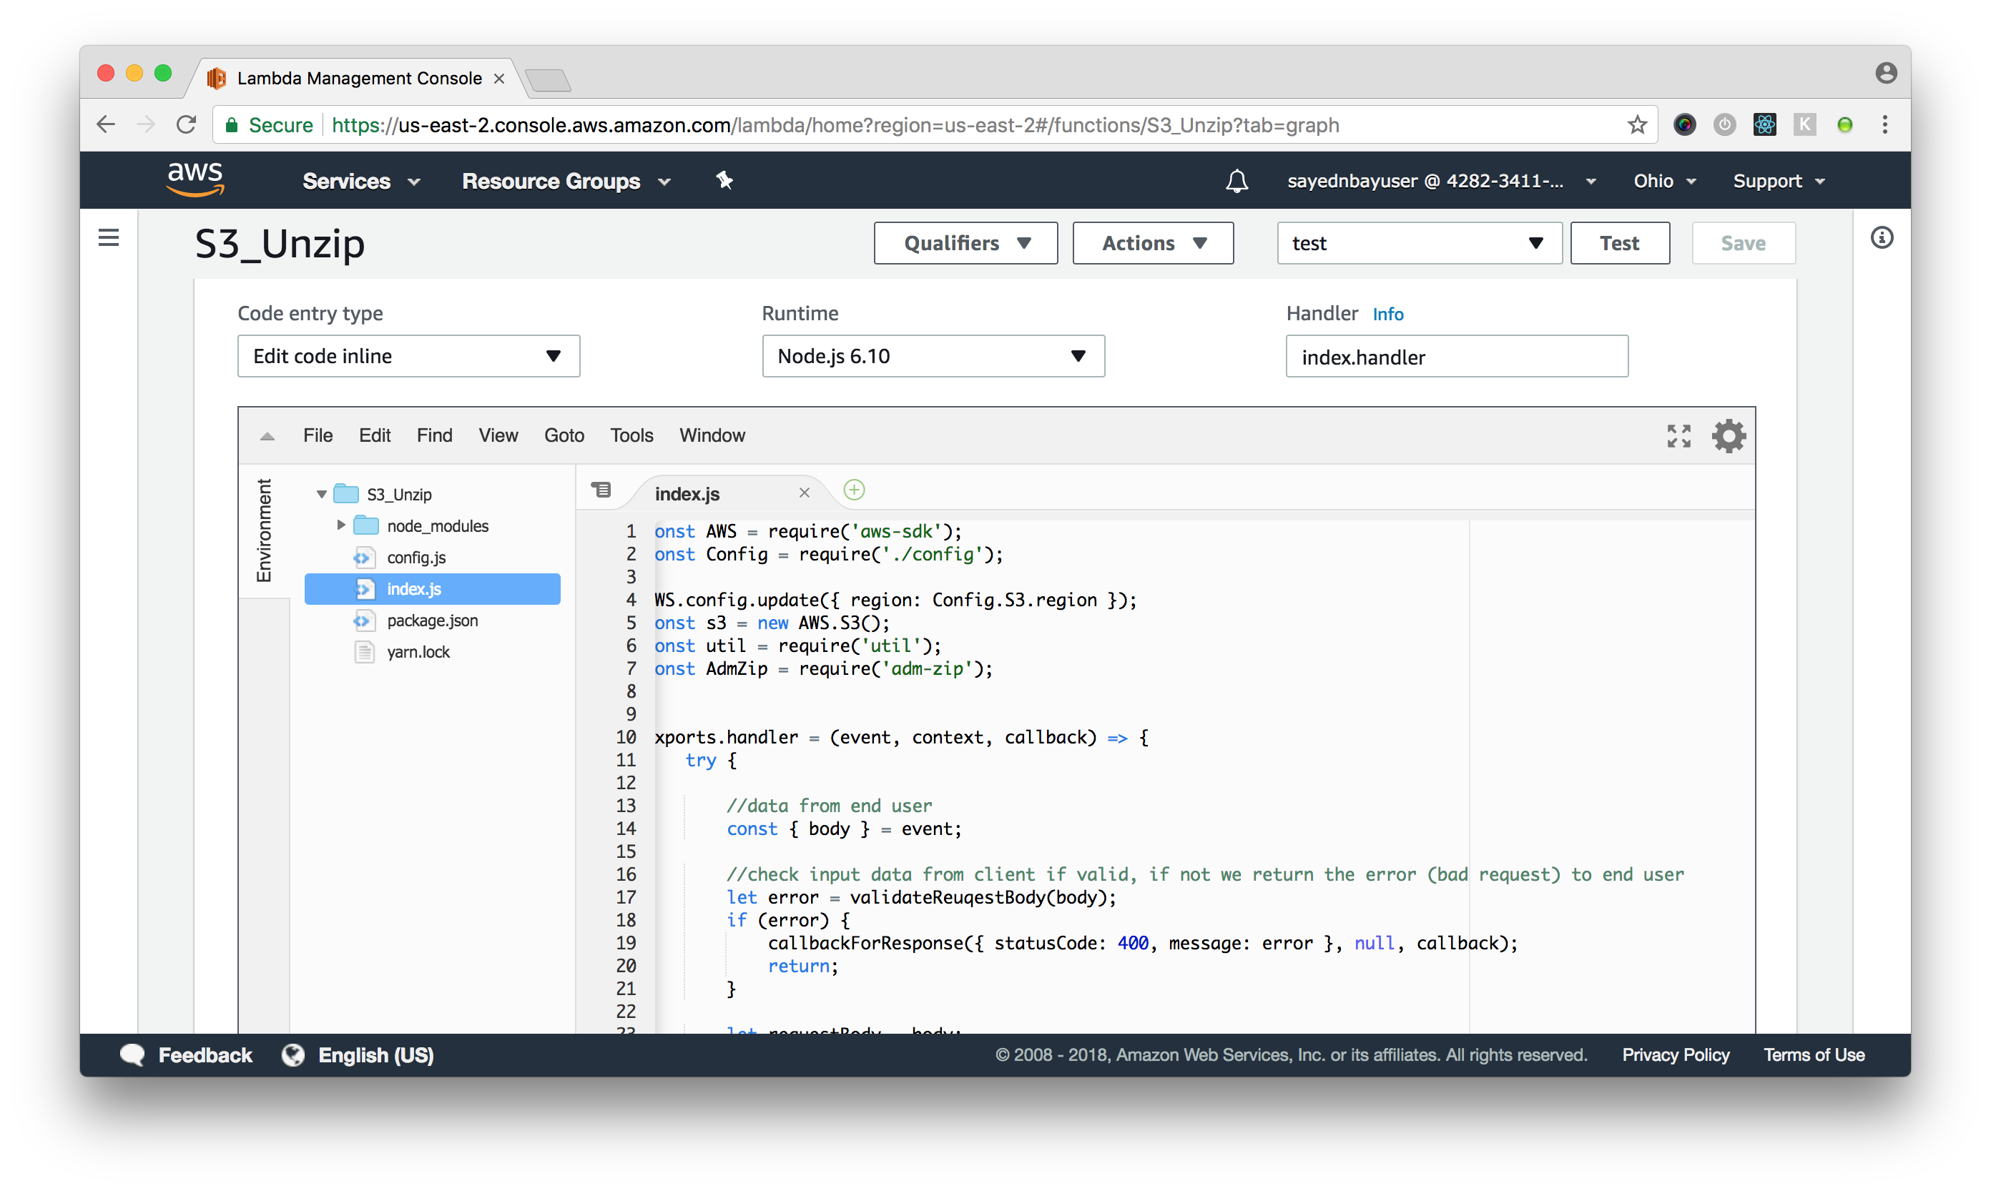

1. Create api gateway “S3-Unzip”, enable COR, setup the lambda function above as proxy

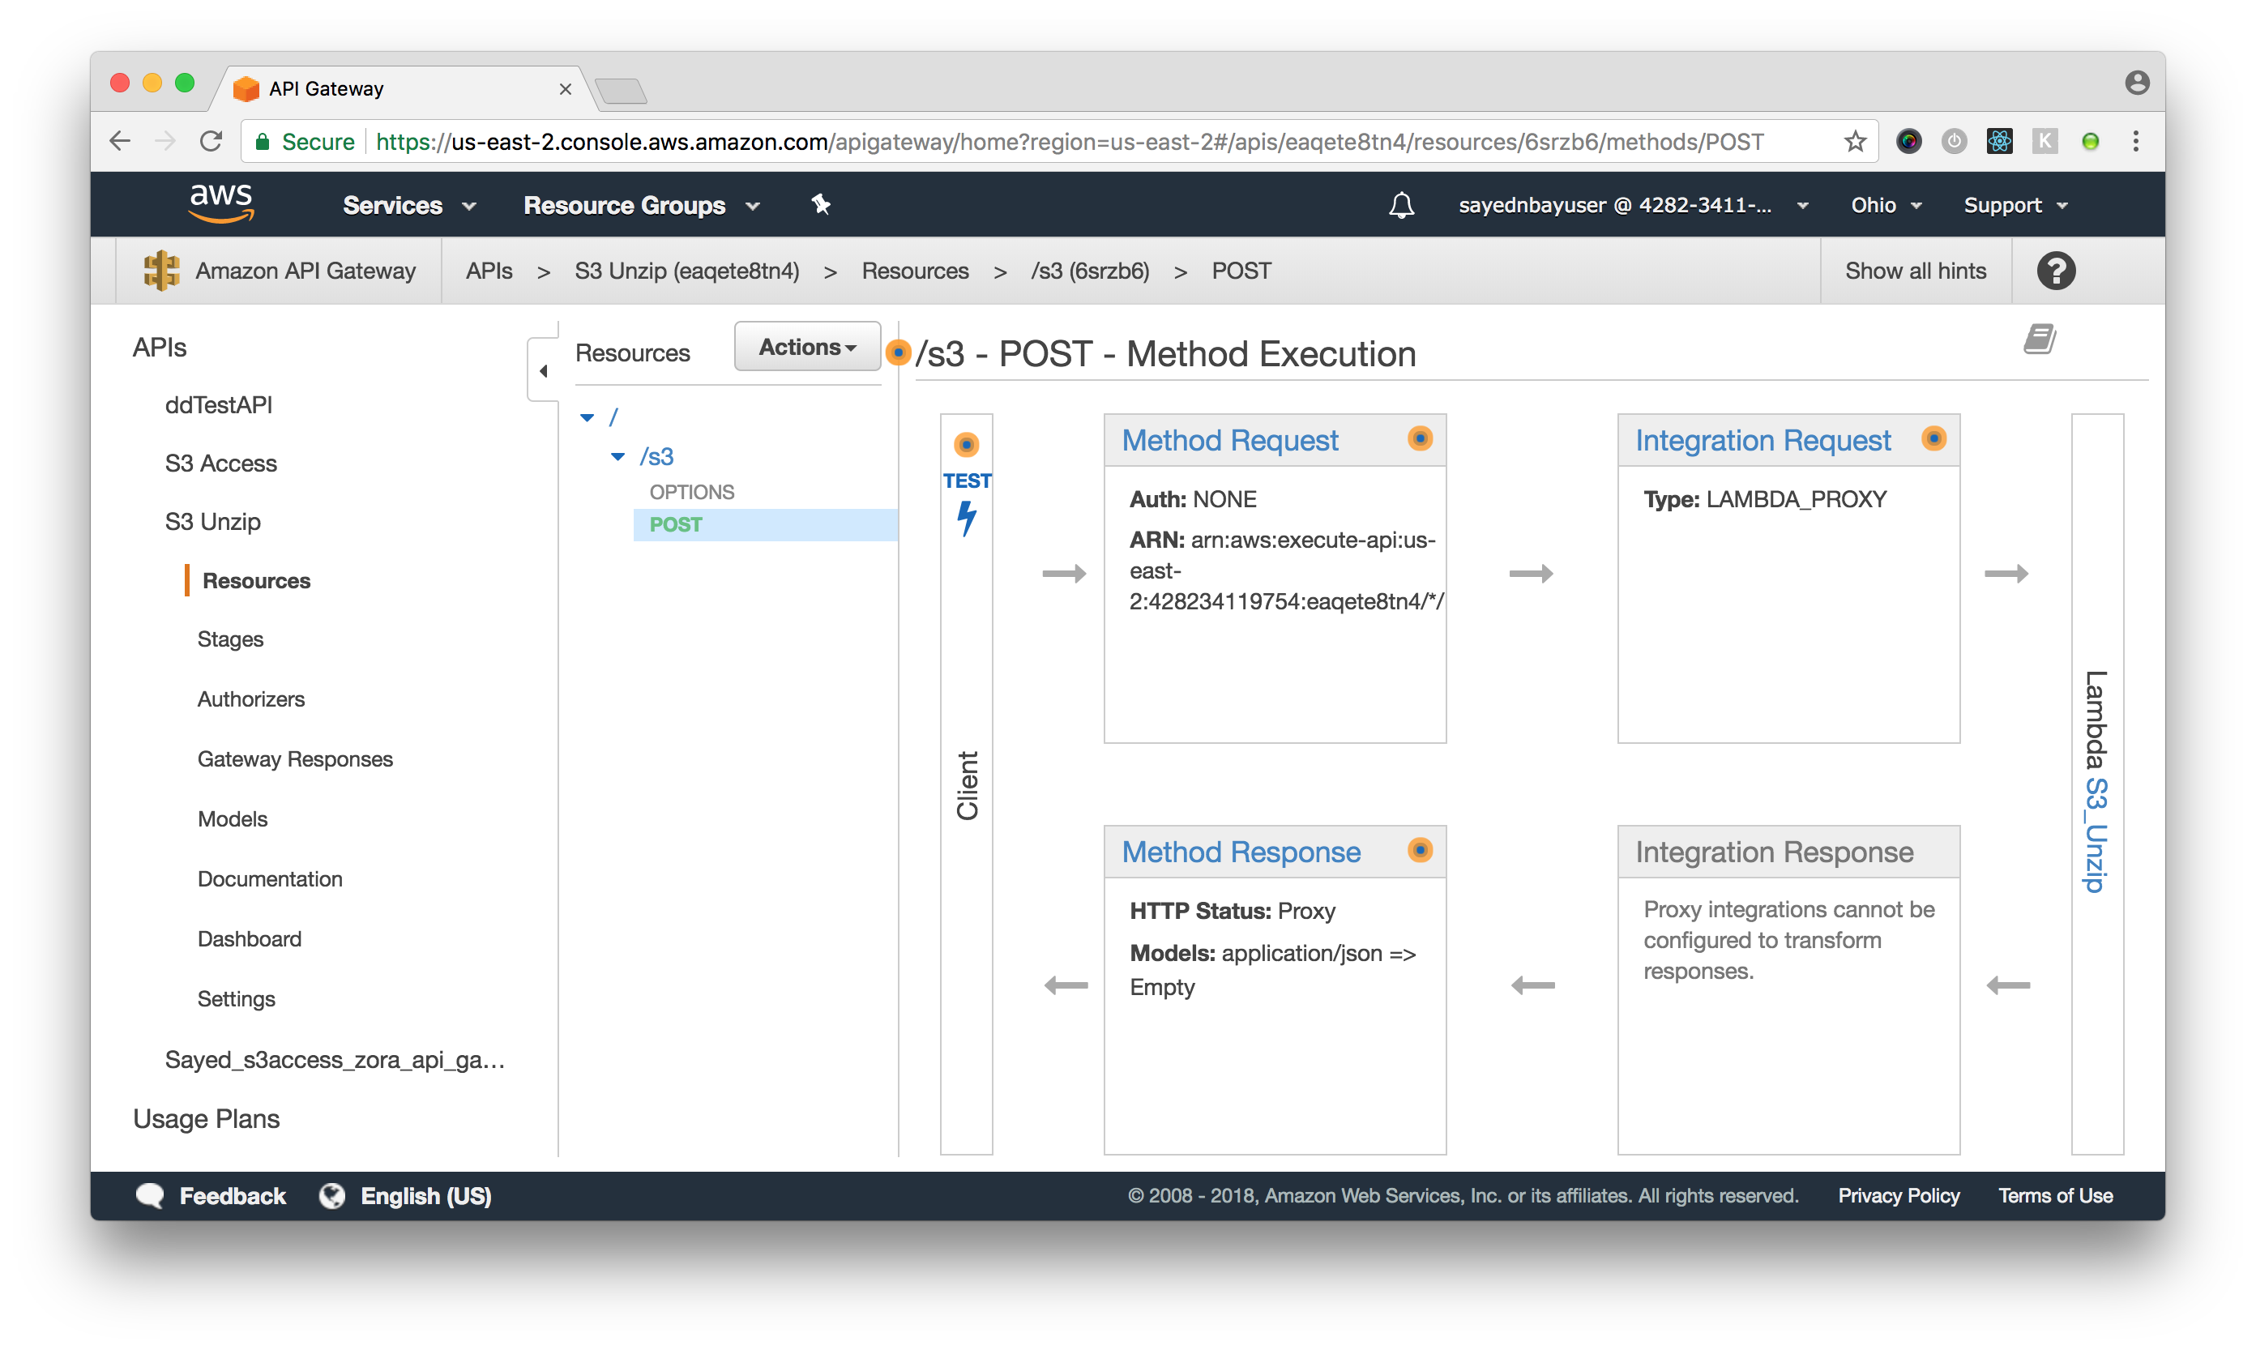

1. Deploy the API to “Test” stage

then endpoint is “<https://eaqete8tn4.execute-api.us-east-2.amazonaws.com/test>”



after these setup, you can run the node console “aws-unzip-console” which invoke the api gateway to unzip file in s3.

Before run it, you should make sure node.js is installed on your pc.

<https://nodejs.org/en/>